**COVID 19 ANALYSIS BETWEEN JANUARY 2020 AND MARCH 2023 USING MICROSOFT EXCEL.**

The image below shows the consolidated dataset for all cases of death, confirmed and recovered along with the date, longitude and latitude and countries of occurrence. The data has 330327 records consisting of 201 countries.

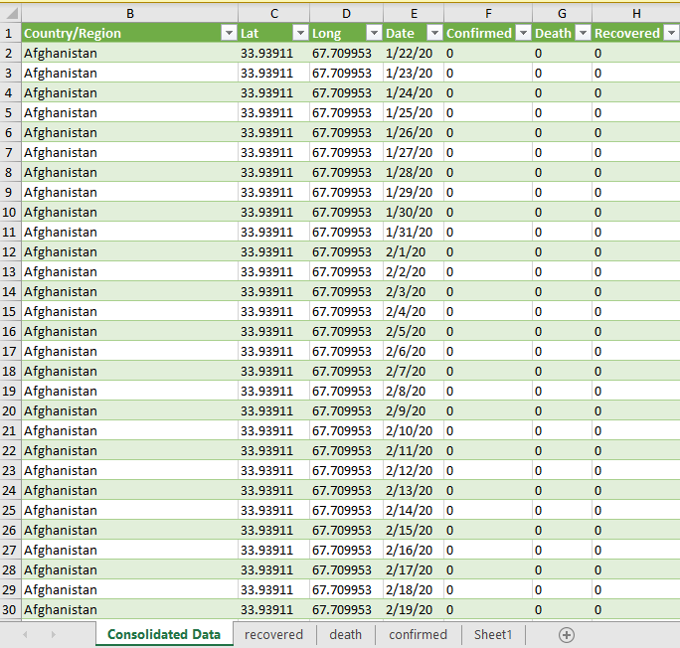

This image below shows an update of the previous image reflecting the extracted year, month, and day of occurrence as the analysis progressed.

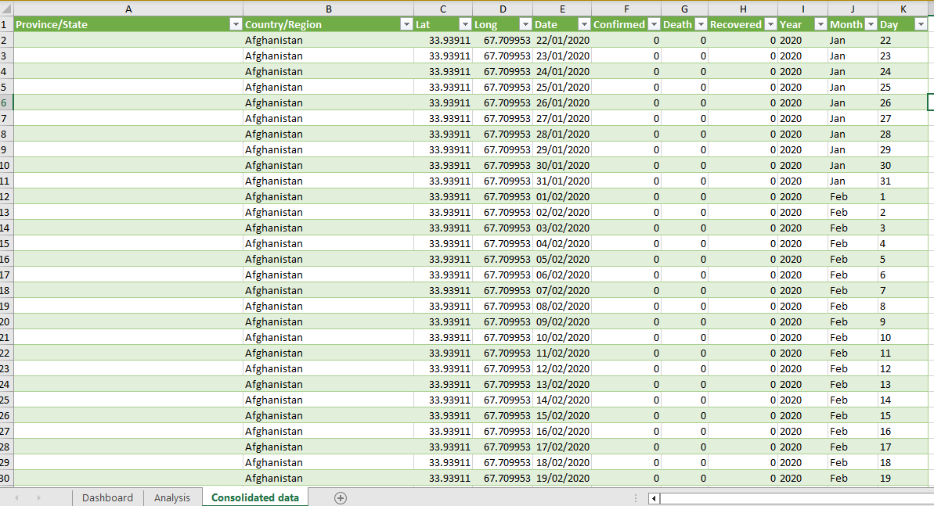

The image below shows the analysis page making use of pivot tables to compute each record for the dashboard to be built after now.

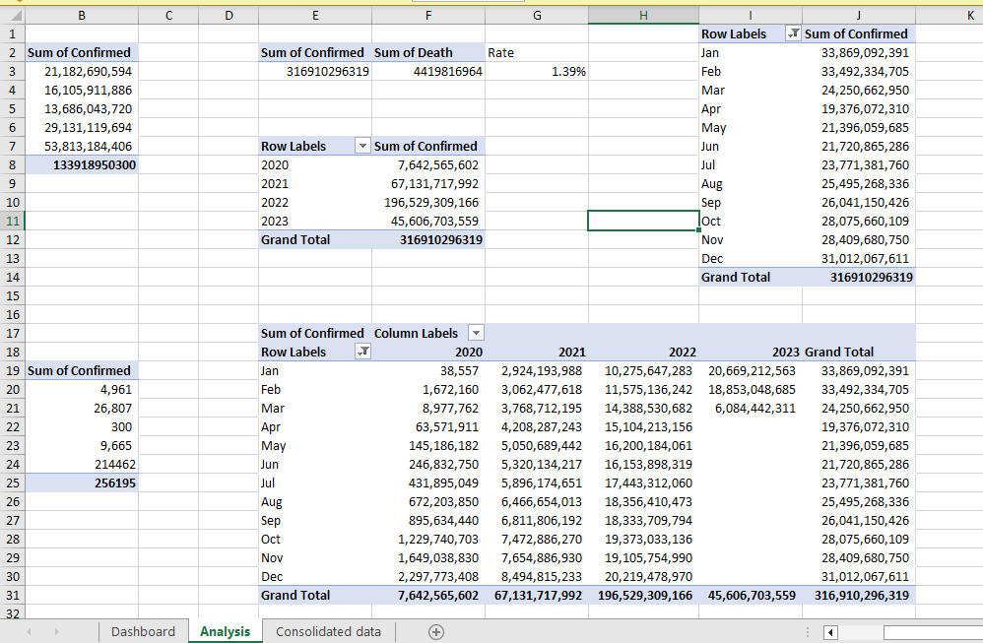

The image below shows the Covid 19 analysis dashboard of the prevalence of the disease by year in different countries over the stipulated period.

